MAKE THIS YEAR’S ELECTION MATTER!

This year’s election has captured the world’s attention. But what can YOU do to make sure your elected leaders do what’s best for the American people, especially our most vulnerable?
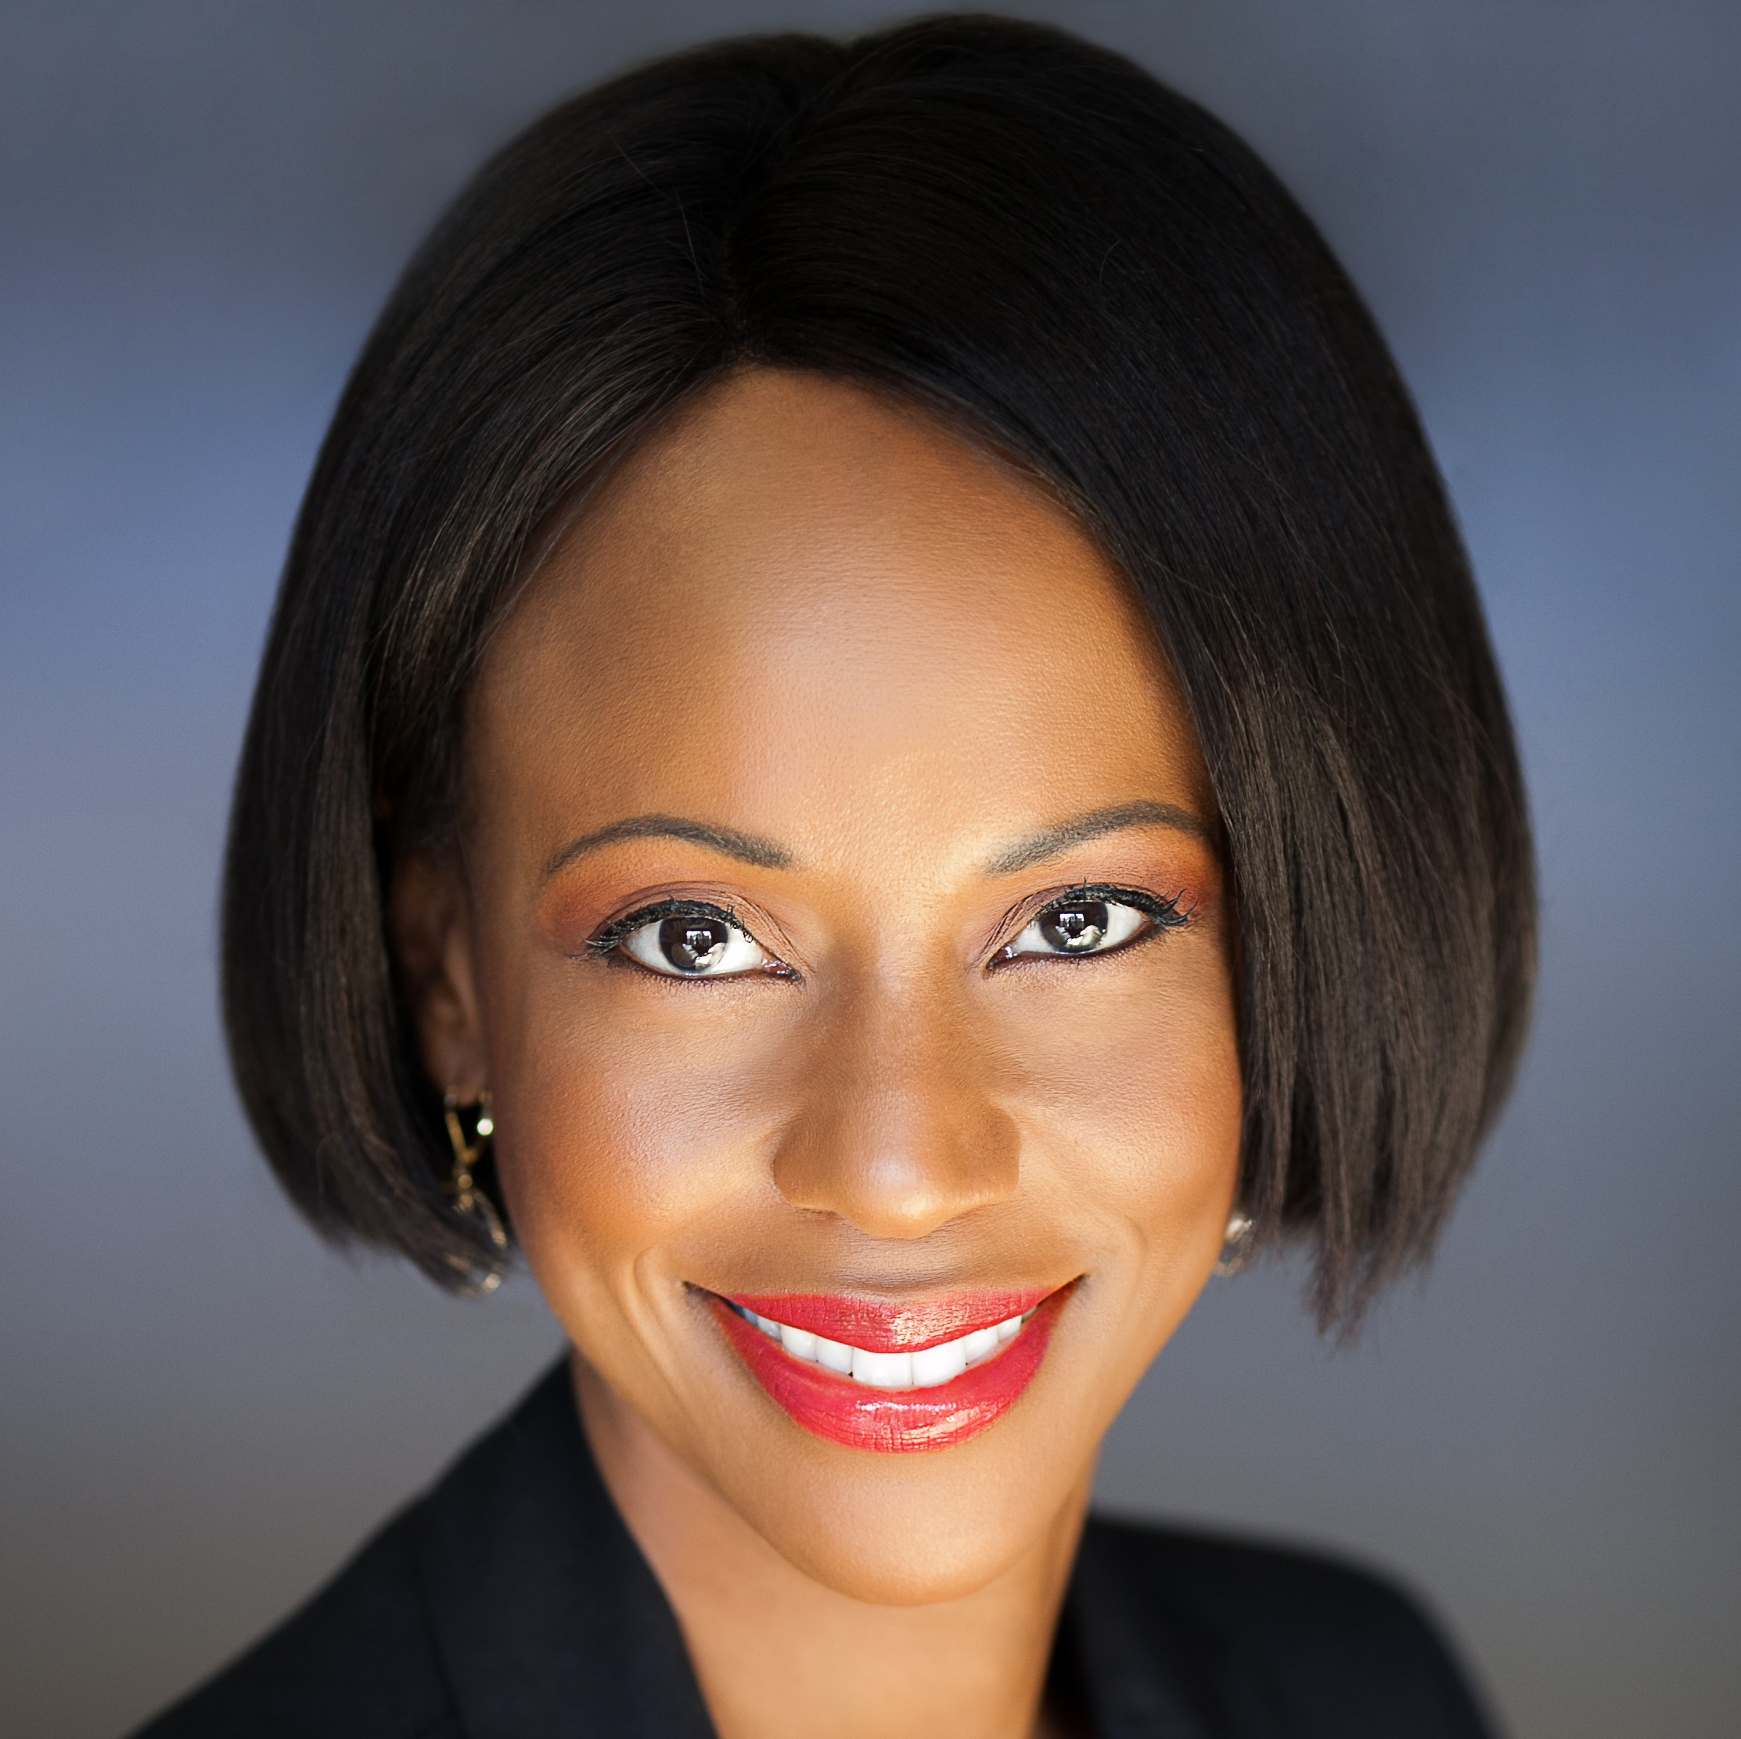
RESULTS is a movement of passionate, committed everyday people using their voices to influence political decisions that will bring an end to poverty. We’re hosting a National Webinar with Dr. Maya Rockeymoore. Dr. Rockeymoore leads the Global Policy Solutions and is a renowned expert on practical solutions to poverty.
Join us to learn how you can make this election matter!
WHEN: November 15, 8pm ET
WHERE: [enter local meeting info]
For questions, please contact [local contact)
www.results.org
@RESULTS_Tweets
RESULTSEdFund
@Voices4RESULTS

MAKE THIS YEAR’S ELECTION MATTER!

This year’s election has captured the world’s attention. But what can YOU do to make sure your elected leaders do what’s best for the American people, especially our most vulnerable?
RESULTS is a movement of passionate, committed everyday people using their voices to influence political decisions that will bring an end to poverty. We’re hosting a National Webinar with Dr. Maya Rockeymoore. Dr. Rockeymoore leads the Global Policy Solutions and is a renowned expert on practical solutions to poverty.
Join us to learn how you can make this election matter!
WHEN: November 15, 8pm ET
WHERE: [enter local meeting info]
For questions, please contact [local contact)
@Voices4RESULTS
RESULTSEdFund
@RESULTS_Tweets
www.results.org

