Wealth Inequality and the Racial Wealth Gap
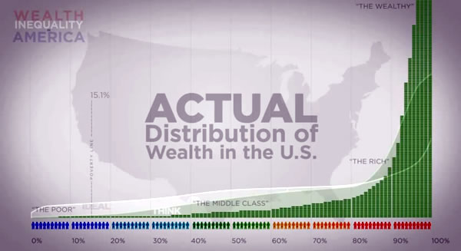
As the income inequality debate has gained traction over the last few years, the conversation has often ignored wealth inequality and the racial wealth gap. In 2013, the top one percent owned 40 percent of the nation’s wealth and the bottom 40 percent owned almost nothing. In 1963, the families in the highest income brackets had six times the wealth of families in the middle; in 2013, they had twelve times the wealth.

Within wealth inequality, the racial wealth gap is incredibly prominent. The racial wealth disparity is so striking that:
- In 2011, for every $1 dollar that White Americans held in wealth, Black Americans held only 6 cents and Latino Americans held only 7 cents.
- In 2000, Native American median wealth was only 8.7 percent of all Americans’ median wealth.
- In 2007, White women’s median wealth was $45,400 compared to Black women’s median wealth at just $100 and Latina women at $120.
- 38 percent and 35 percent of Black and Latino households respectively reported having no financial assets compared to 14 percent of White households.
- A Black or Latino college graduate, on average, held less wealth than a White high school dropout in 2013.
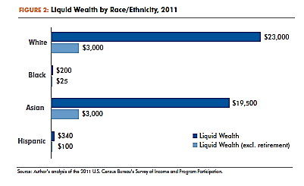
- While the Great Recession affected most American families, the impact was particularly damaging for the assets of families of color. In 2010, the ratio of White wealth to Black wealth was 10:1; by 2013, that ratio increased to 13:1. Similarly, the ratio of White wealth to Latino wealth grew from 9:1 to 10:1 2010-2013.
- In 2011, less than half of Black and Latino households and less than 60 percent of Asian households owned a home compared to almost three-fourths of White households. Less than six out of ten Native Americans owned their homes in 2007. This disparity in homeownership is the single largest driver in the creation of the wealth gap.
Homeownership has had a critical role in families amassing wealth as well as sustaining the racial wealth gap. The U.S. tax code includes over half a trillion in tax benefits—deductions, credits, exclusions and preferential rates—that incentivize households to build wealth. Many of these tax benefits subsidize homeownership for millions of Americans; unfortunately, those subsidies are not accessible to many low-income communities and communities of color. Thus, they are not able to take advantage of the $211 billion in homeownership tax subsidies. The racial wealth gap has become a pervasive problem that negatively impacts all communities in the United States and requires immediate action.
The extreme racial wealth inequality has been created and now exacerbated by past discriminatory public policies and the federal tax system. From land-grabbing and slavery to the racial exclusion from the middle class in the mid twentieth century, the United States has a long history of marginalizing communities of color. The consequences, however, are still largely felt across the country as families of color have not been provided the opportunity to save, invest, and build wealth in the same capacity that White families have been provided. Understanding America’s history and tax system is fundamental to creating equitable public policies, especially as Congress considers tax reform in the upcoming years.

Financial Social Work: https://www.financialsocialwork.com/blog/video-wealth-inequality-in-america
The Urban Institute: http://datatools.urban.org/Features/wealth-inequality-charts/
Center for Global Policy Solutions (CGPS): http://globalpolicysolutions.org/wp-content/uploads/2014/04/Beyond_Broke_FINAL.pdf
Economic Policy Institute: http://www.epi.org/publication/bp370-native-americans-jobs/
CGPS: http://globalpolicysolutions.org/resources/wealth-gap-women-color/#prettyPhoto[gallery1572]/0/
CGPS: http://globalpolicysolutions.org/wp-content/uploads/2014/04/Beyond_Broke_FINAL.pdf
Demos: http://www.demos.org/blog/9/23/14/white-high-school-dropouts-have-more-wealth-black-and-hispanic-college-graduates
Pew Research Center: http://www.pewresearch.org/fact-tank/2014/12/12/racial-wealth-gaps-great-recession/
Demos: http://www.demos.org/publication/racial-wealth-gap-why-policy-matters
Insight Center for Community Economic Development: http://www.insightcced.org/uploads/CRWG/Racial%20Gap%20in%20Homeownership%20Spring%202009.pdf
Institute for Assets and Social Policy: http://iasp.brandeis.edu/pdfs/2015/RWA.pdf
CFED: http://cfed.org/assets/pdfs/Upside_Down_to_Right-Side_Up_2014.pdf
CFED: http://cfed.org/blog/inclusiveeconomy/upside_down_the_211_billion_budget_to_house_the_wealthiest_homeowners/

