Protect Hungry Families by Rejecting Cuts to SNAP
Please protect SNAP, a vital program for millions of low-income Americans, by speaking directly to congressional leadership urging them to strongly oppose cuts to Supplemental Nutrition Assistance Program (SNAP, formerly food stamps), including oppose efforts to use SNAP as an offset to pay for other crucial safety net programs.
SNAP (Formerly Food Stamps) is a Lifeline for Millions
Because of low wages and the ongoing impact of the Great Recession, millions of Americans are struggling to put food on the table. In 2013, more than 1 in 5 children in the U.S. were at risk of going to bed hungry every night (21 percent, according to USDA). Studies show that children who are regularly hungry suffer from weakened immune systems, slowed and abnormal growth, and anemia. Children in families that do not struggle against hunger tend to be healthier, while young children from food-insecure households are two-thirds more likely to be at risk of developmental problems than those from households with enough to eat.
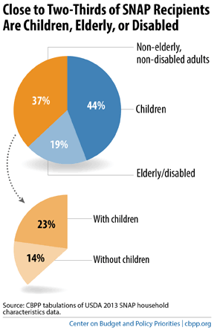
The Supplemental Nutrition Assistance Program (SNAP, formerly food stamps) is the first line of defense against hunger in America. Currently, nearly 48 million people — almost half of them children — receive SNAP benefits. SNAP lifted almost 5 million people out of poverty in 2013 (US Census). Nearly 90 percent of SNAP participants are in households that contain a child under age 18, an elderly person 60 years or older, or a disabled individual. SNAP has been found to significantly reduce hunger and poor health in children.
SNAP helps working families make ends meet and get on their feet. More than half of SNAP households with at least one working-age, non-disabled adult, and more than 60 percent of households with children, work while participating in SNAP. SNAP is also structured as a work incentive: for every additional dollar a SNAP recipient earns, her SNAP benefits decline by only 24 to 36 cents. Families that receive SNAP thus have a strong incentive to work more hours or search for better-paying jobs. Moreover, CBO has found that SNAP has one of the largest increases in economic activity for every budgetary dollar spend among a broad range of policies for stimulating economic growth. Finally, SNAP is one of the most efficiently run programs, with 99 percent of benefits going to eligible households.
Cuts to SNAP Will Hurt Vulnerable Families
Despite the importance of SNAP for millions of families and recent completion of the Farm Bill in 2014 (which included cuts to SNAP), we are very concerned that Congress may look again to make deep cuts to SNAP. In 2010, SNAP was cut to pay for improvements to child nutrition programs – a precedent RESULTS does not want to see repeated. Let’s not compromise the health and well-being of America’s families by once again cutting SNAP.

