Create Economic Mobility by Protecting and Strengthening the EITC and CTC
Please speak directly to congressional leadership, particularly House Ways and Means Committee Chairman Paul Ryan and Ranking Member Sander Levin or Senate Finance Committee Chairman Orrin Hatch and Ranking Member Ron Wyden, urging them to make working families their top priority in any tax legislation. Specifically, urge them to:
- Save key provisions of the Earned Income Tax Credit (EITC) and Child Tax Credit (CTC) that help millions of hard-working families meet ends meet by making expiring provisions in those credits permanent.
- Fix the glaring gap in the EITC by expanding it for low-income, childless workers and non-custodial parents.
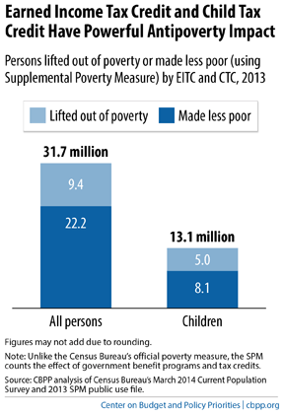
The EITC and CTC Support Working Families
The Earned Income Tax Credit (EITC) and Child Tax Credit (CTC) are pro-work, pro-family financial lifelines for people working in low-wage jobs. The evidence shows that:
- The EITC and CTC encourage work. Only taxpayers who are working can claim the credits, and they encourage people to work more hours. In fact these pro-work credits did as much or more to raise employment among single mothers as welfare reform, extensive research shows.
- The EITC and CTC help families make ends meet and improve the lives of children. Children in families receiving the EITC do better in school, are more likely to attend college, and earn more income as adults.
- The EITC and CTC lift millions of people out of poverty each year and is our best tool for reducing poverty among children.
- The EITC and CTC are good for local economies. EITC and CTC refunds tend to get spent quickly and locally. Economist Mark Zandi estimated that the EITC generates at least $1.24 in economic activity for every $1 spent, and the CTC generates $1.38 for every $1 dollar spent.
In January 2013, Congress extended key provisions to ensure that families who make under $13,000 per year can still claim a partial CTC and preserved the current EITC for married couples and larger families. But, Congress must act to make these provisions permanent; if they are allowed to expire in 2017, more than 50 million Americans, including 25 million children, will lose part or all of their tax credits. In particular:
- 16 million Americans, including 8 million children, will fall into or deeper into poverty.
- Some 1 million veteran and armed-forces families would lose all or part of their EITC or CTC.
In addition, Congress must fix the glaring gap in the EITC by expanding it for childless adults, including young workers. Currently, adults without children in the home (including non-custodial parents who pay child support) receive a very small EITC (maximum of $500), and consequently, these workers are the only group that the tax code actually taxes into or deeper into poverty. House Ways and Means Chair Paul Ryan, President Obama, and others have proposed expanding the EITC for childless workers and lowering the eligibility age for this credit from 25 to 21. These changes would benefit 13.5 million Americans, including 1.5 million non-custodial parents, and would lift 500,000 hardworking Americans out of poverty.
Right now, Congress is considering tax legislation and extending some business tax credits. During this debate, Congress must continue to support hardworking families by keeping key provisions of the EITC and CTC intact for working families, and look for opportunities to fix the gap in the EITC for workers without children.

